Scripting Task

Task 1:
Create a file with .sh extension.
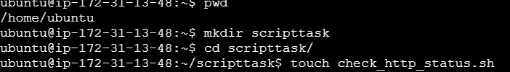
Open the file using vi command and write the script
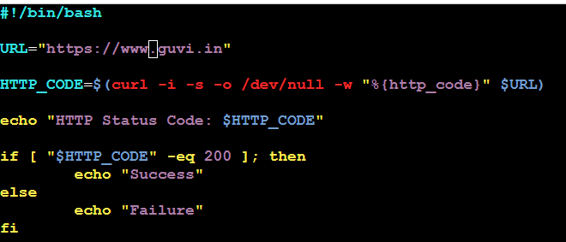
Here we are using curl to get the HTTP status code
# -s: Silent mode
#-i: option to display the HTTP response headers
# -o /dev/null: Discard the actual response body
# -w "%{http_code}": Print only the HTTP status code

Once the code is written, save the file with :wq and give the execute permissions to the file
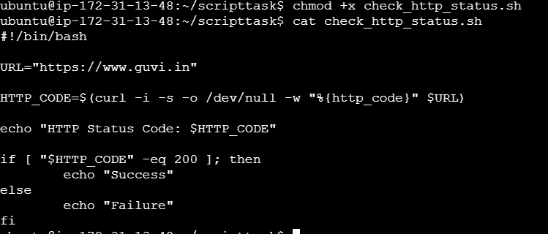

Run the file using ./check_http_status.sh command and below is the output
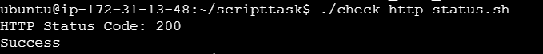

Task 2:
Create a file with some text in it as below
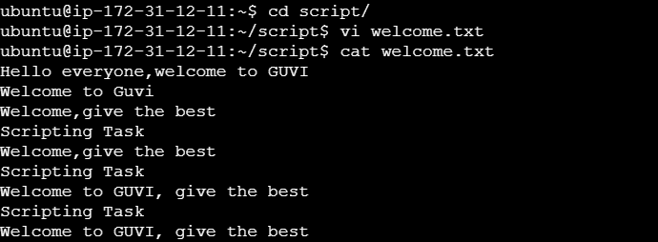

Use sed command to specify a line range and a pattern match before executing a substitution
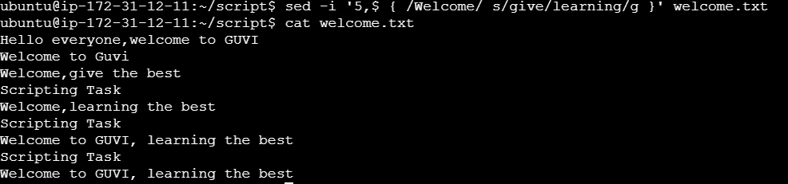
- -i flag to modify the file directly
- 5,$: Defines the range from the 5th line to the end of the file ($).
- { /welcome/ ... }: Only performs the command on lines that contain "welcome".
- s/give/learning/g: Substitutes "give" with "learning." The g flag ensures all occurrences on the line are replaced.

